Turing’s imitation game

3 players

A man

B woman

C interrogator (male/female)

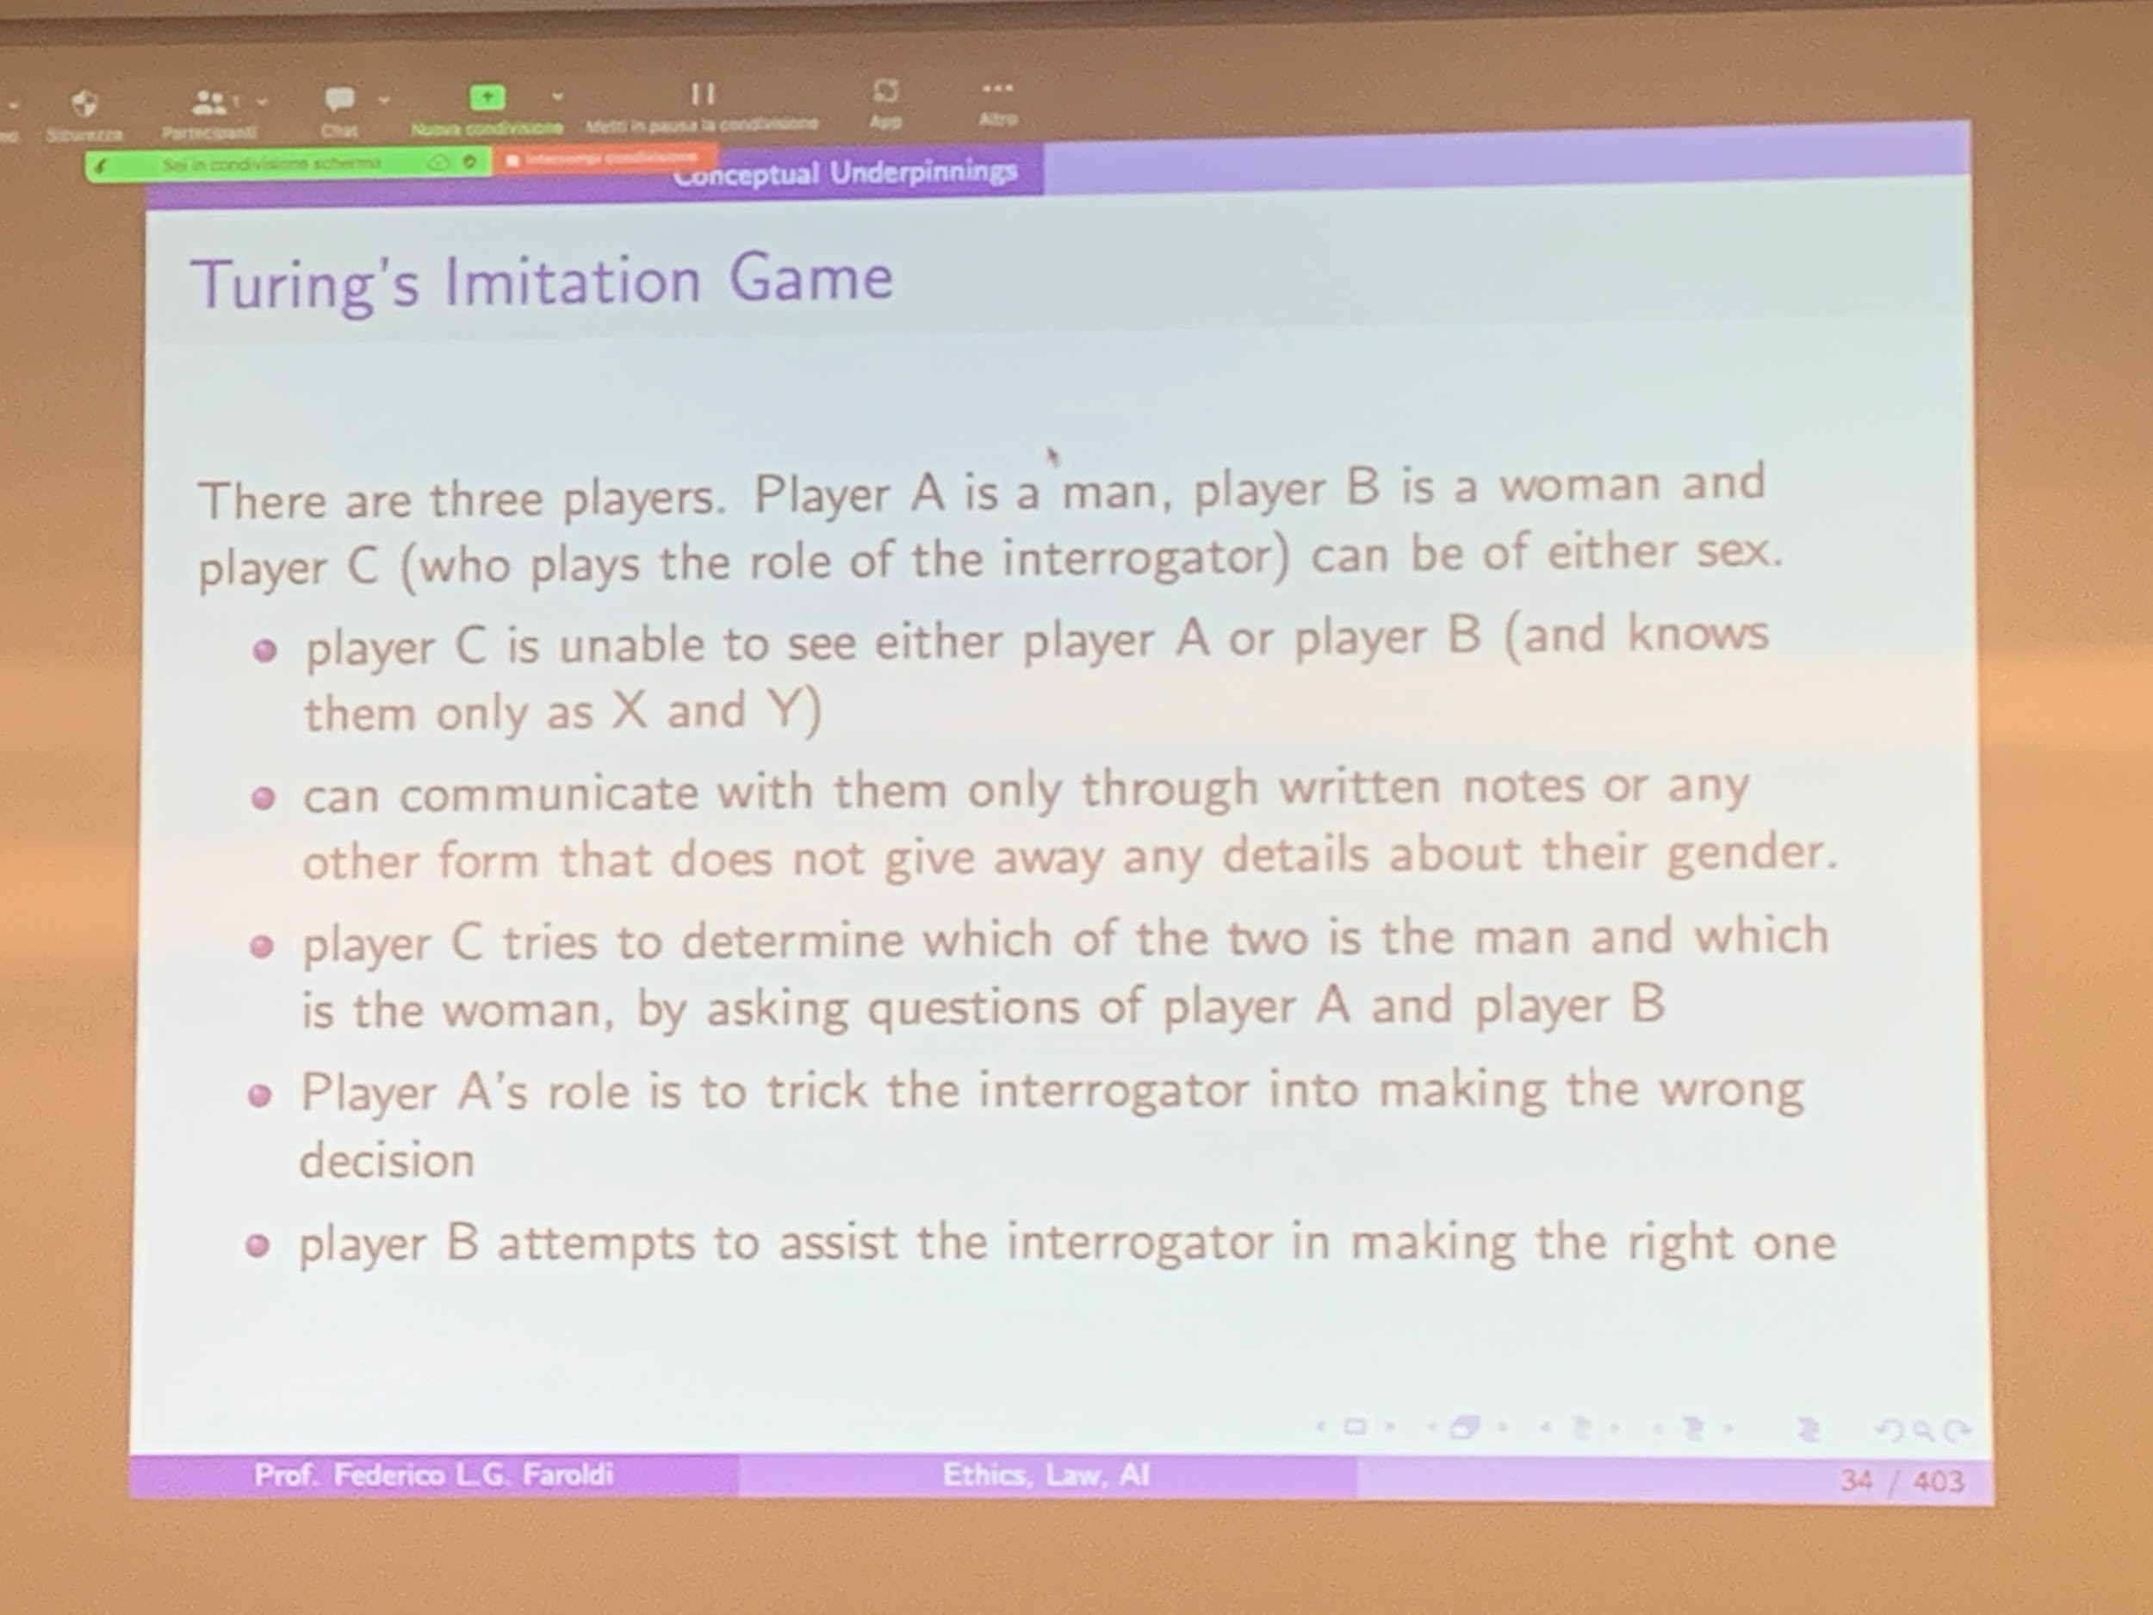

VICTORY